**SOFTWARE ENGG. PROJECT**

**On**

**Airline Reservation system**

**Submitted By –**

**Shivansh Bhardwaj**

**2017UCP1515**

**Acknowledgement**

**This is a certified work done by Shivansh Bhardwaj under the guidance of**

**Prof. Girdhari Singh**

**Tools Used :-**

**Front-End=HTML,CSS,JS,Bootstrap**

**Back-End=PHP,Mysql**

**About Project**

**A Web Application of Airline Reservation System with Customer and Admin login with many features as Create_User,Forgot_password**

**Customer Can:**

* + **Book Flight Tickets for a particular date between selected cities**
  + **View booked tickets**
  + **Cancel booked Tickets**

**Admin Can:**

* **Add new jet**
* **Add new flight**
* **Cancel a flight**
* **View booked ticket Statistics**

**AIRLINE RESERVATION SYSTEM**

**PROBLEM DEFINITION**

Ticket reservation system for airlines has to be developed.

The system developed should contain the following features:

1. Search for information about the flight by means of origin, destination and departure date.

2. While displaying information about the flight it has to provide availability of

seats.

3. While reserving tickets the system obtain following information from the user

* Passenger Name
* Sex
* Age
* Credit Card Number
* Bank Name.
* Flight number
* Flight name
* Date of Journey
* Time of Journey
* Meal Requrement
* Number of tickets to be booked.
* Access to Lounge
* Insurance details
* Access to Premium Service

4. Based on the availability of tickets, the ticket has to be issued. The ticket issued should contain the following information –pnr number, flight no, transaction no, flight name, date of journey, number of passengers, sex, age and departure time.

5. Cancellation of booked tickets should be available

6.Admin should be able to add new Jet details

7 Admin should be able to add new Flight details for a particular date

8 Admin should be able to activate or deactivate a particular jet

9 Admin should be able to delete flight details

10 Admin should be able to view booked Flight Statistics for a particular date

**SRS DOCUMENT FOR AIRLINE**

**RESERVATION SYSTEM**

* **INTRODUCTION**
* **Purpose**
* The purpose of this SRS is to describe the requirements involved

in developing a Airline Reservation system (ARS).

* The intended audience is any person who wants to reserve or

cancel tickets or to check the availability of Airline tickets

* **Scope**
* The product is titled Airline Reservation system (ARS).
* The product will perform the following tasks -
* The software that is being developed can be used to check the

availability of the flight tickets for the specified flight, destination

and date of journey.

* If the tickets are available to the users needs and specification, then

the software provide a facility to book the tickets.

* If the passengers wants to cancel the tickets, he can use the

cancellation module of the Airline Reservation System.

* Admin can add new flight and delete the flight
* Admin can view statistics of booked tickets
* Admin can add a new jet and activate or deactivate it
* **Definitions, Acronyms and Abbreviations**
* ARS: Airline Reservation System.
* **References**
* IEEE standard 830-1998 recommended practice for Software

Requirements Specifications-Description.

* **Overview**
* The SRS contains an analysis of the requirements necessary to help easy

design.

* The overall description provides interface requirements for the Airline

Reservation system, product perspective, hardware interfaces software

interfaces, communication interface, memory constraints, product

functions, user characteristics and other constraints.

* Succeeding pages illustrate the characteristics of typical naïve users

accessing the system along with legal and functional constraints

enforced that affect Airline Reservation system in any fashion.

* **THE OVERALL DESCRIPTION**

**Product perspective**

* Hardware interfaces

Hard disk: The database connectivity requires a hardware

configuration with a fast database system running on high rpm

hard-disk permitting complete data redundancy and back-up

systems to support the primary goal of reliability.

The system must interface with the standard output device,

keyboard and mouse to interact with this software.

* Software interfaces

Back End: PHP,MySQL

Front End: HTML,CSS,JS,Bootstrap

* Operations

The user mode enables the end-users to do the end user operations

like checking the availability, reserving and cancelling of flight

tickets.

**Product Functions**

* Viewing Flight Details

The user must have the access up-to-date information about the flights

including

* Flight number
* Flight Name
* Flight route(Start and Destination stations)
* Flight timings
* Seat availability
* Reserving Tickets

The user must be able to reserve tickets after selecting

Flight number

Flight Route

* Cancelling Tickets

The user must be able to cancel tickets that he has earlier reserved by

quoting the pnr number.

**User characteristics**

* The intended users of this software need not have specific knowledge

as to what is the internal operation of the system. Thus the end user is

at a high level of abstraction that allows easier, faster operation and

reduces the knowledge requirement of end user

* The Product is absolutely user friendly, so the intended users can be the

naïve users.

* The product does not expect the user to possess any technica l

background. Any person who knows to use the mouse and the keyboard

can successfully use this product.

**Constraints**

* At the time of reservation, each user is provided a unique pnr number

that must be used for further operation like cancellation. Hence the user

is required to remember or store this number carefully.

* **SPECIFIC REQUIREMENTS**

**Logical Database Requirements**

* The system should contain databases that include all necessary

information for the product to function according to the requirements.

* These include relations such as flight details, ticket details, and

payment details.

* The user details refer to the information such as flight number and

name, start and destination stations, seat availability.

* ticket details refer to personal information that is obtained from

the user

* At the time of reservation, the passenger is provided a unique pnr no

that could be used at the time of cancellation.

* While displaying any information about the flight it has to provide the

following information -

* Flight no and name
* Availability of seats for the particular flight
* The flight timing
* The passenger personal details should be obtained for reserving tickets
* **FRONT – END DESCRIPTION**

The front-end for the Airline Reservation system (ARS) is designed using HTML,CSS,JS,Bootstrap. The front-end contains a user- friendly interface. The home page contains Welcome Screen with Login Tab. After Login, The Customer Dashboard contains a welcome screen that provides an option for the user to select one of the following

* Book tickets
* Cancel tickets
* View booked tickets

The Admin Dashboard contains a welcome screen that provides an option for the admin to select one of the following

* View booked ticket Statistics
* Add a new Flight
* Delete a Flight
* Add a Jet
* Activate Jet
* Deactivate Jet

In the Book Tickets form the user can get details of the flight by means of flight

name destination and date 0of journey. In the reservation form, user can book details by

entering the personal details such as passenger name, age, sex, frequent flier Id. The ticket is displayed with details about the flight name and pnr number, name of passengers, sex, age, meal options, primary lounge options. The cancellation form helps

the user to cancel a ticket, which he had booked earlier with the help of pnr number.

* **BACK – END DESCRIPTION**

The technology used in back-end is PHP and MySQL Database is used. The Airline Reservation system consists of eight tables. One contains the flight details such as the flight name, flight number, destination, date of journey and seats available in each

class that is referred to during enquiry. Another table has the passenger details such as

name, age, sex, credit card number, pnr no. This table is referred to at the time of

reservation or cancellation. Another table is payment details that contain all the payment information such as pnr no, transaction no, payment date, payment amount and mode. Another table is jet details table that contain all the information about a particular jet such as jet id, jet capacity, brand name. Another table is admin table that contain info about all admins of the application such as admin username and password. Another table is customer table that contain all the information about customer user name and password. Another table is frequent flier details, that contain all the info about frequent fliers such as their special id and mileage.

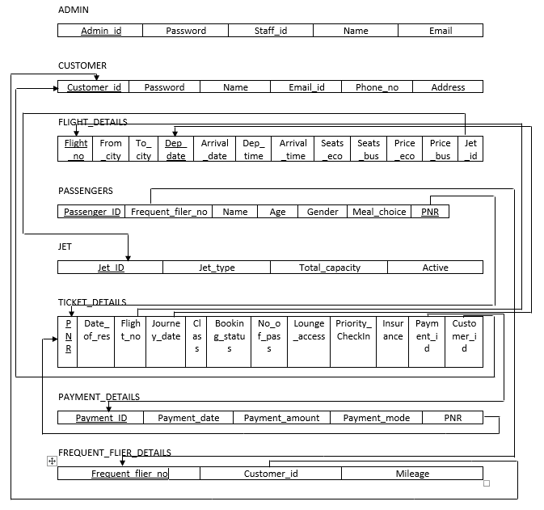

**LOGICAL STRUCTURE:**

**Customer**

customer_id->

pwd,name,email,phone_no,address

Bcnf Form

**Admin**

admin_id->

pwd_type,staff_id,name,email

Bcnf Form

**Jet_details**

jet_id->

jet_type,jet_type,total_capacity,active

Bcnf Form

**Flight_details**

flight_no,departure_date->

from_city,to_city,arrival_date,departure_time,arrival_time,seats_economy,seats_business,price_economy,price_business,jet_id

Bcnf Form

**Ticket Details**

**pnr**->

date_of_reservation,flight_no,journey_date,class,booking_status,no_of_passengers,lounge_access,priority_checkin,insurance,payment_id,customer_id

Bcnf Form

**Payment_details**

**payment_id**->

pnr,payment_date,payment_date,payment_amount,payment_mode

Bcnf Form

**Passengers**

**passenger_id,pnr->**

**name**,age,gender,meal_choice,frequent_flier_nos

Bcnf Form

**Frequent_flier_details**

**frequent_flier_no->**

customer_id,mileage

Bcnf Form

**ER DIAGRAM**

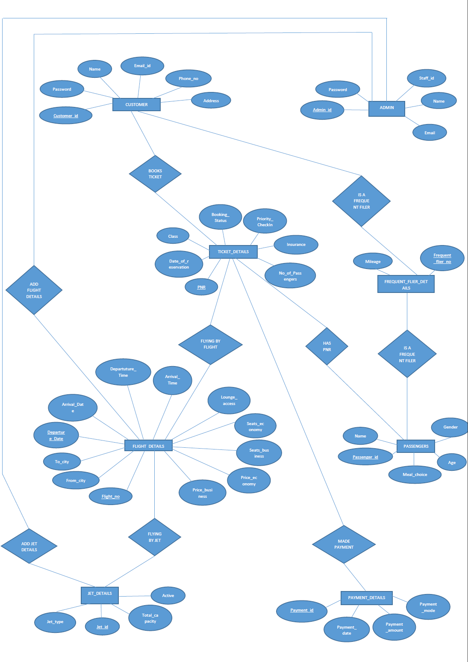

**Modules In the Project :**

customer_homepage.php

Displays the customer dashboard after customer login

admin_homepage.php

Displays the admin dashboard after admin login

login_handler.php

Authenticate valid user by username and password by matching from customer table and start session if success

logout_handler.php

Logout a user by ending the session

new_user_form_handler.php

Registers a new user by taking input all the necessary details and inserting them into customer table

book_tickets.php

Inputs the flight requirements from user such as departure and arrival details and number of passengers and redirects to view_flights_form_handler

view_flights_form_handler.php

Displays all the flights that meets the user requirements. User select a flight for booking and redirects to book_tickets2.php.Prices are Dynamic.

book_tickets2.php

User is required to enter all the required details for ticket booking such as passenger names, age and choice of meal.

add_ticket_details_form_handler.php

It processes all the passengers information and redirects user to payment page.

payment_details.php

It displays all the payment modes and amount to be paid.

payment_details_form_handler.php

It handles the payment and if payment is success, redirects to ticket_success page.

ticket_success.php

It displays that ticket is successfully booked.

forgot_pass_handler.php

It handles the forgot password request and redirects user to window where he can create new password only if details given by user are verified.

view_booked_tickets.php

It helps the user to view tickets from tickets table in database having the given cust. id

cancel_booked_tickets.php

It helps the user to cancel the tickets booked having the provided pnr number by customer.

add_flight_details_form_handler.php

It helps the admin to add new flight into the flight_details table with the help of jet_id.

add_jet_details_form_handler.php

It helps the admin to enter details of a new jet and give it a unique jet_id

view_booked_tickets_statistics_form_handler.php

It helps the admin to view number of tickets booked for a particular day

by querying into ticket_details table.

activate_jet_details.php and deactivate_jetdet.php

Admin can activate and deactivate a jet so that it can be used to schedule a flight or not

**Other Nonfunctional Requirements:**

**Performance Requirements**

* The Airline Website shall have capabilities to accept 500 connections. For each session, system shall guarantee the connection time 5 minutes from last input, after which the connection will be deemed expired. A close operation will be performed when expired. This design is to satisfy each user’s usability and connection quality.
* The system shall send out verification request immediately (within 100ms) after it receives a user submitted form.
* The system shall update all flight status information every 5 minutes.

**Security Requirements**

* All exchanges from client to server involving private data shall occur using the highest available level of secure connection (e.g., https).
* SQL Injections should be prevented by use of bind parameters
* Cross Site sctipting should be prevented
* Md5 hashing algo must be used for encrypting passwords

**Usability**

The airline website design shall allow deployment on both Windows and UNIX(Linux) servers. The design should support Windows Server 2003, Linux 2.6.x, V10UNIX and later.

**Robustness**

The system design shall include recovery scenarios allowing the ability to restore a state no older than one business day old

**DFD LEVEL 0**

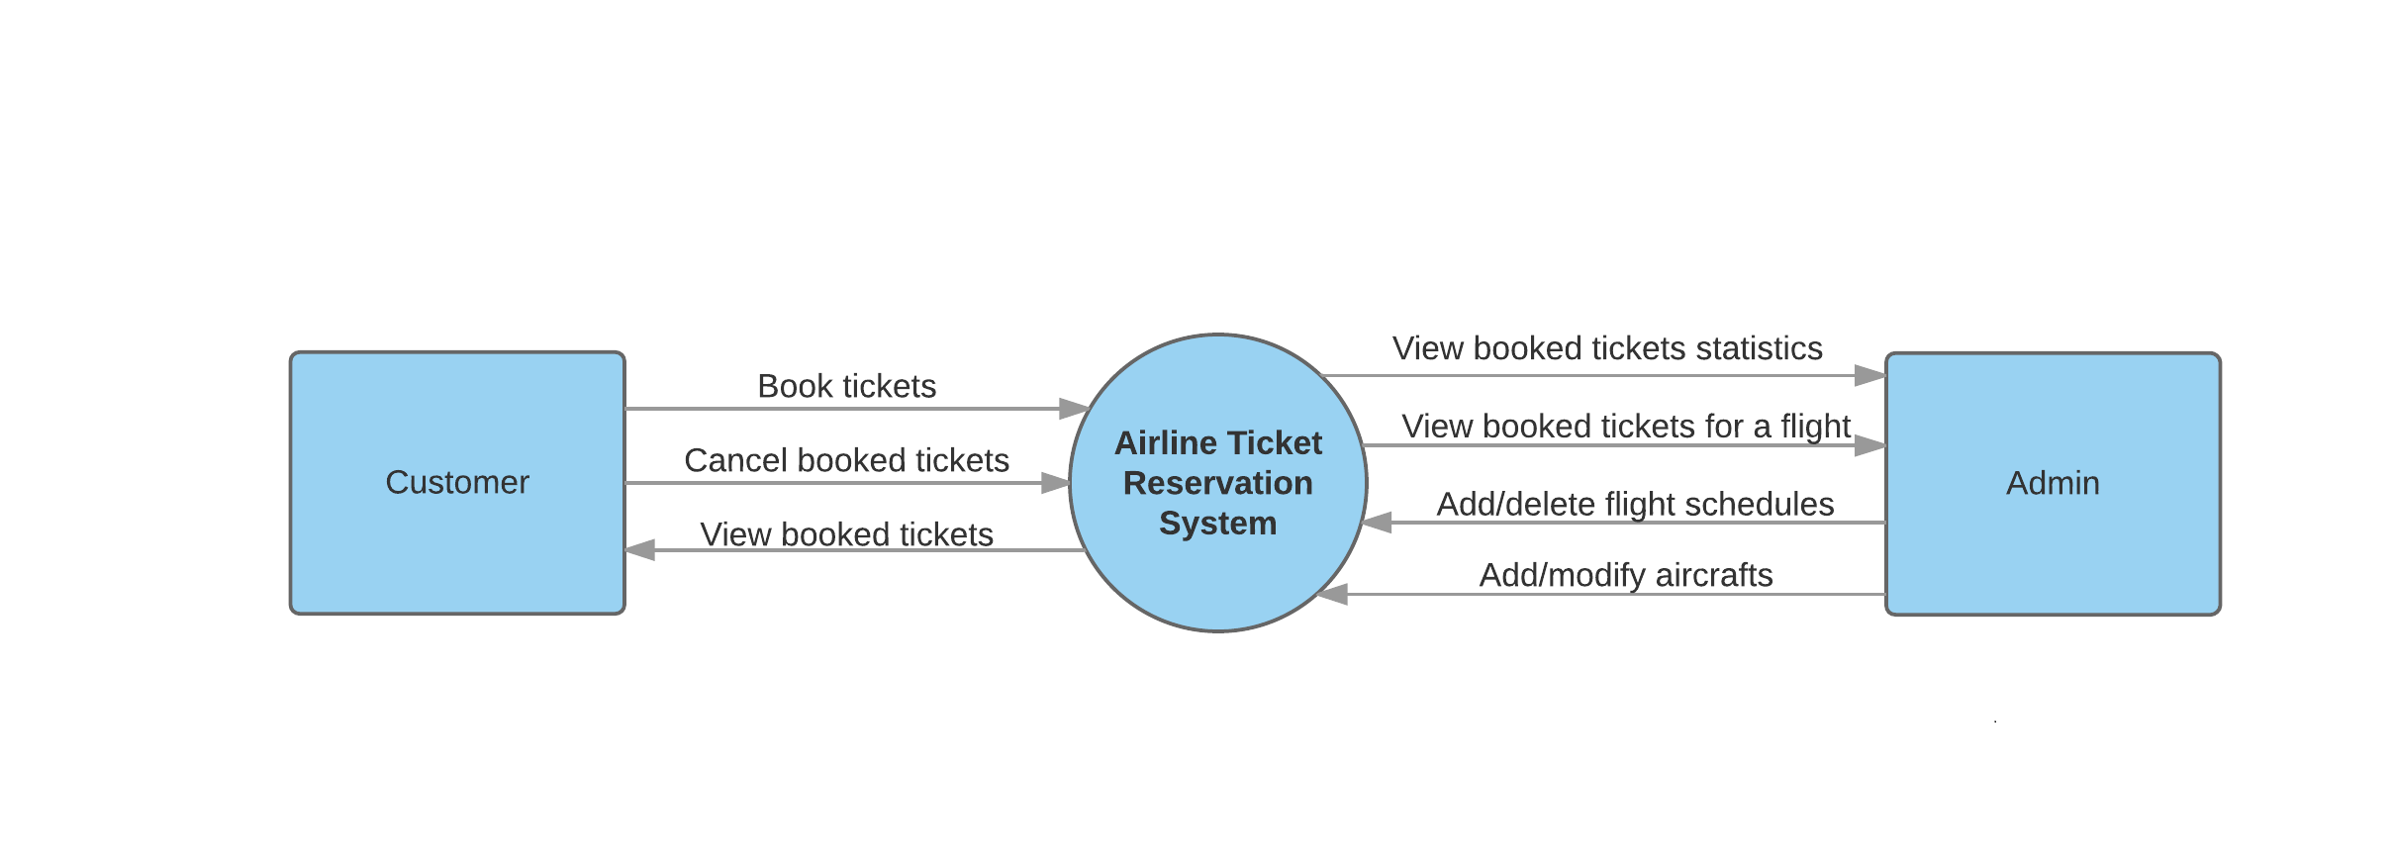

**DFD LEVEL 1**

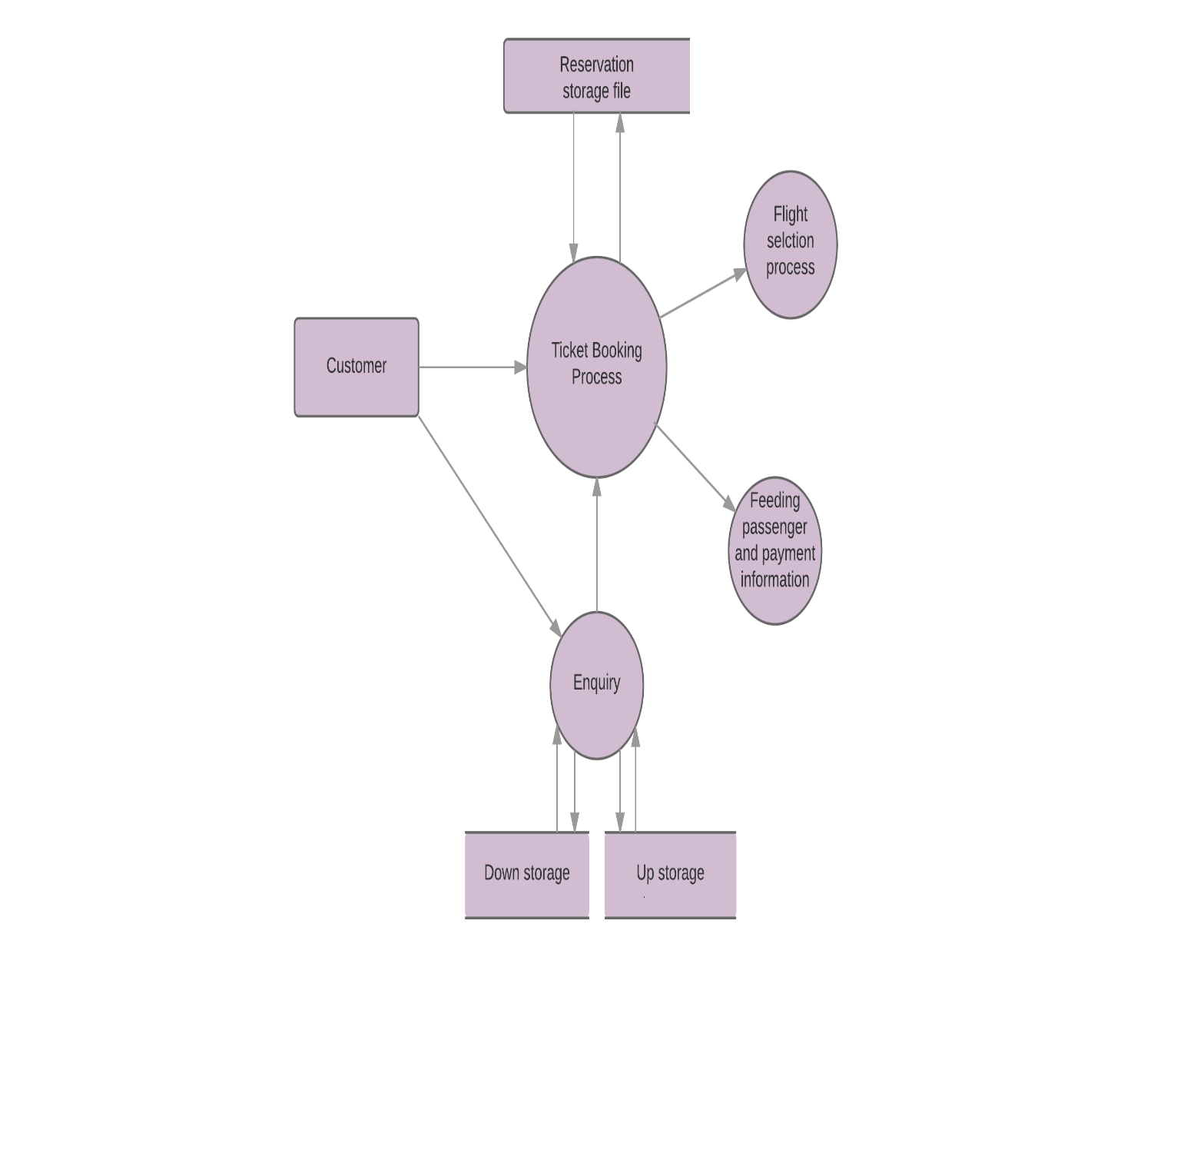

**DFD LEVEL 2**

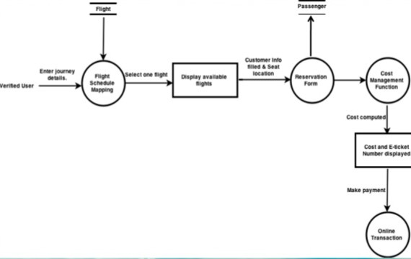

**ACTIVITY DIAGRAM**

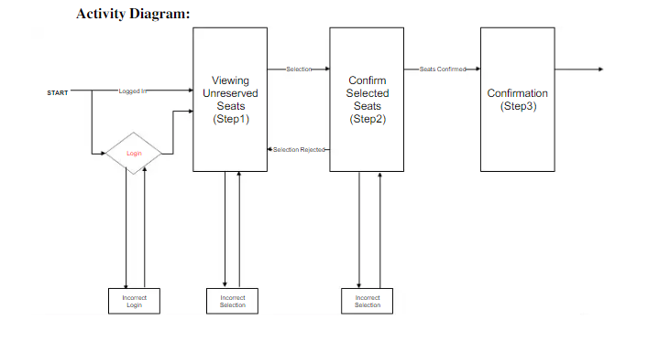

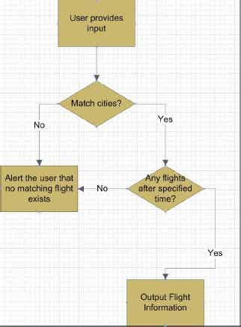

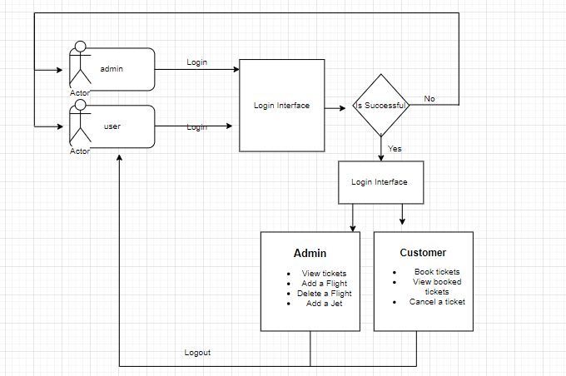

**Sequence Diagram**

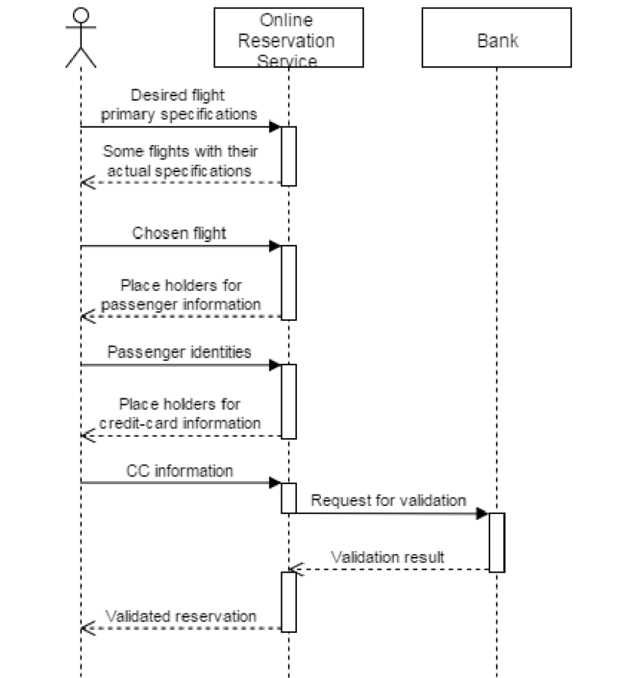

**USE CASE DIAGRAM**

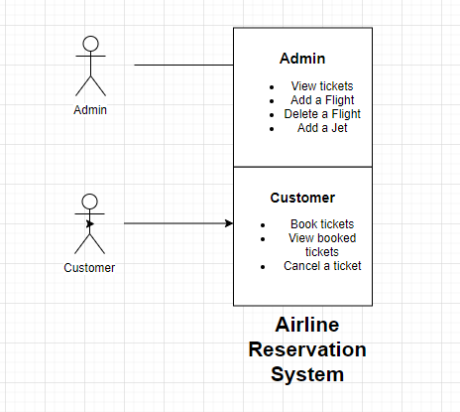

**TESTING**

|  |  |  |  |  |
| --- | --- | --- | --- | --- |
| **FORM NAME** | **INPUT** | **EXPECTED OUTPUT** | **ACTUAL OUTPUT** | **STATUS** |
| MAIN MENU  FORM | Menu Option | Required Form  must be  displayed | Required form  was displayed. | Pass |
| TICKET  AVAILABILITY  FORM | Flight route and Date | Flight seats  availability must  be displayed | Flight seats  availability are  displayed | Pass |
| RESERVATION  FORM | Personal details  were entered. | Ticket must be  booked and  database  updated. | Ticket was  booked and  database was  updated. | Pass |
| CANCELLATION  FORM | PNR number  was entered. | Ticket must be  cancelled and  database must  be updated | Ticket was  cancelled and  database was  updated.. | Pass |
| LOGIN FORM | Login Id and Password Entered | User Dashboard must be displayed | User Dashboard was displayed | Pass |

**Result:**

All the major modules passed the unit tests and integration tests.